In 2007, the IOC passed a motion to create a dynamic and exciting sports event aimed specifically at the youth of the world.

The XIII Olympic Congress declared that “youth and athletes are equally at the heart of the Olympic Movement.” IOC President Jacques Rogge further commented that; “We will find new ways to share the Olympic values with the world’s youth and get them involved in sport. We will redouble our efforts to protect the health and safety of athletes, and help them prepare for life after sport.”

The Congress further commented that the new Youth Olympic Games would be “a unique opportunity in the history of the modern Olympic Movement to raise the bar worldwide in terms of the delivery of educational and sport programmes for all young people.”

The first ever Summer Youth Olympic Games, will be held in 2010 in Singapore (14th-26th August). The Games will unite approximately 3,600 athletes (14yrs-18yrs), and 1,450 officials, from 205 NOC’s. The inaugural Winter Youth Olympic Games will held in 2012 in Innsbruck (13th-22nd January), involving approximately 1,000 athletes and 500 officials. There will also be many opportunities for youths to participate in the Games in a non-sporting capacity, such as reportage or ambassadorships. The event is an exciting landmark for the IOC, with President Jacques Rogge commenting:
“The first ever Youth Olympic Games will be an important moment for the Olympic Movement. It is the first time we have launched a new event since the first ever Winter Games in 1924.”

Sale of Broadcasting Rights
MediaCorp, SingTel and StarHub signed up to become the official broadcasters of the Games within Singapore. Coverage of the Singaporean Games will incorporate all broadcast platforms, including free-to-air television, radio, cable television, mobile phone and online. In relation to the media agreement, Rogge commented: “Today’s announcement is a big step forward in ensuring that the Youth Olympic Games are available to viewers on all broadcast platforms, both within Singapore and around the world.” It can be observed that the sale of media rights has formed a central focus of the IOC’s strategy to deliver the Youth Games to spectators all over the world.

The YOG Culture & Education Programme
The structure of the Games require young athletes to a) participate in high-level sporting competition and b) participate in a Culture and Education Programme (CEP) which focuses on five key themes: Olympism and Olympic values, skills development, well-being and healthy lifestyle, social responsibility and expression through digital media.
Innsbruck 2012 has harnessed the power of networking technology to offer a unique sporting and cultural experience for young people participating in, and watching the Games. The Organising Committee recognise the high global usage of Internet and social networking technologies by the young people who will be participating in these Games, and have subsequently integrated technology into the Games as a central part of the Games experience.
The two-community, two-cluster compact winter sports plan and Culture and Education Programme (ECP) offers each young participant an opportunity to collaborate across cultures in the creation of athlete-generated Internet content, using media platforms as diverse as print, TV, radio, photography and the Internet. This content will then be shared with the world during the Games.

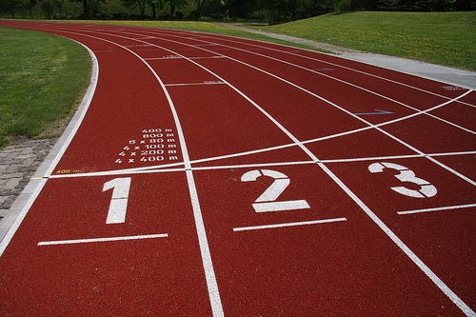
Image created by nchenga and reproduced under a Creative Commons licence.

Structure of the Games
The Games will be held in a quadrennial cycle, following the cyclical format of the Olympic and Paralympic Summer and Winter Games.
The inaugural Summer YOG will encompass all 26 sports on the programme of the 2012 Olympic Games, with a smaller number of disciplines and events, and some adaptations (for example, some disciplines will be non-Olympic with mixed gender or/and mixed NOC events.

Singapore 2010 Friendship Camp

The Singapore 2010 Friendship Camp (SFC) runs from 8th – 12th December 2009, and will seek to unite young athletes from across the world. A total of 417 participants (262 student athletes from 130 NOC’s and 155 student athletes from Singapore, aged between 15 and 17) will attend, and the goal of the event is to promote the Olympic values of Excellence, Friendship and Respect to all of the young people in attendance. An exciting range of activities will be run throughout the duration of the Camp.

Mr Masagos Zulkifli, Senior Parliamentary Secretary, Ministry of Education and Ministry of Home Affairs, commented: "In the spirit of Friends@YOG, local participants from the respective twinned schools will be both buddies and hosts to the NOC-participants. I encourage our young participants to foster new friendship bonds across borders grounded in true Olympic values of excellence, friendship and respect, and bring home their experiences to share with their fellow athletes."

The Million Deeds Challenge
The Singapore 2010 Youth Olympic Games Million Deeds Challenge was launched by Ms Grace Fu, Senior Minister of State for National Development and Education. The Million Deeds Challenge (www.milliondeeds.sg) invites all Singaporean youths to join in the Youth Olympic movement by celebrating the spirit of Olympism via deeds of Excellence, Friendship and Respect. Mr Ng Ser Miang, Chairman of the Singapore Youth Olympic Games Organising Committee (SYOGOC), commented that,

"Through the Million Deeds Challenge, we want to start and sustain a Youth Olympic movement that everyone can be part of."

The Million Deeds Challenge, a microsite of the Singapore 2010 website, allows Singaporeans to post their deeds of Excellence, Friendship and Respect, and share them with others. Designed to resemble a virtual Torch Relay, every deed posted will move the virtual Youth Olympic flame a step closer from Greece to Singapore.

Anti-Doping Measures at YOG
The YOG Anti-Doping Seminar 2009 will run throughout the duration of the Games, in conjunction with the Singapore National Olympic Council (SNOC), the Singapore Youth Olympic Games Organising Committee (SYOGOC) the Singapore Sports Council (SSC), the World Anti-Doping Agency (WADA) and the Japan Anti-Doping Agency (JADA).
The inaugural Winter Games will encompass all seven Winter Olympic sports, again involving a smaller number of disciplines and events.

Innsbruck Youth Winter Games 2012

Certified accountant Richard Rubatscher has been announced as the new Chairman of the Supervisory Board for the Winter Olympic Games 2012. Rubatscher has committed himself in particular to logistical and financial considerations to ensure a smooth running of the Games; “Top priority has been the creation of a well-grounded budget to ensure smooth operations without aftermaths".

Looking Forward to Rio
The Youth Summer Olympic Games will bring the Olympic Federation to the South American continent for the first time in Olympic history. Innsbruck, 2012 Winter Games hosts, have already issued congratulation to Rio de Janiero for winning the right to stage the 2016
Youth Games. Austrian athlete Nina Reithmayer (artificial track, 4th overall World
Cup 2009) no doubt spoke on behalf of many of her athletic peers when she expressed her happiness at the idea of a Youth Games 2012 in Innsbruck: "Especially for young athletes, it is important to participate in big events. This is how the motivation and ambition for training grows and it gives you the right "kick" in order to provide world class performances.”
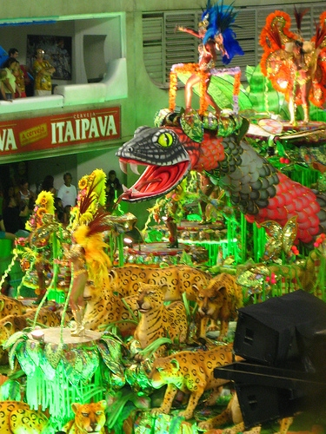
Image created by kaspercarissa and reproduced under a Creative Commons licence.

Historical Use of Sport to develop Values in Youth
Pierre de Coubertin, founding father of the Modern Olympic Movement, based much of his ideas of the moral virtues and educational use of sport on his early experiences of reading about the British public school model of sport. De Coubertin likely favoured one of the most popular boys’ publications of the 1900’s; the Boys Own Paper, that counted Jules Verne and Lord Baden-Powell amongst many of its eminent and legendary columnists. Whilst in parts the publications was undoubtedly jingoistic in it’s’ purveyance of colonial sentiments, it nevertheless did provide an excellent moral standard and education for many young men or higher social classes.
One might consider how the development of the Youth Olympic Games reflects the kinds of morals and ethos that underpinned the writings of the Boys Own Paper; that sport builds character.

FIND OUT MORE
Singapore Youth Olympic Games website
http://www.singapore2010.sg/public/sg2010/en.html

The Olympics website
www.olympic.org

The Olympic Charter http://www.olympic.org/Documents/olympic_charter_en.pdf

Watson, N.J., Weird, S, Friend, S. (2005). The development of muscular Christianity in Victorian Britain and beyond. Journal of Religion & Society, 7.

CREDITS
© Oxford Brookes University 2010. oxb:060111:004cs

This resource was produced as part of the 2012 Learning Legacies Project managed by the HEA Hospitality, Leisure, Sport and Tourism Subject Centre at Oxford Brookes University and was released as an Open Educational Resource. The project was funded by HEFCE and part of the JISC/HE Academy UKOER programme. Except where otherwise noted above and below, this work is released under a Creative Commons Attribution only licence.

Exceptions to the Licence
The name of Oxford Brookes University and the Oxford Brookes University logo are the name and registered marks of Oxford Brookes University. To the fullest extent permitted by law Oxford Brookes University reserves all its rights in its name and marks, which may not be used except with its written permission.

The JISC logo is licensed under the terms of the Creative Commons Attribution-Non-Commercial-No Derivative Works 2.0 UK: England & Wales Licence. All reproductions must comply with the terms of that licence.

The Higher Education Academy logo and the HEA Hospitality, Leisure, Sport and Tourism Subject Centre logo are owned by the Higher Education Academy Limited and may be freely distributed and copied for educational purposes only, provided that appropriate acknowledgement is given to the Higher Education Academy as the copyright holder and original publisher.



Reusing this work
To refer to or reuse parts of this work please include the copyright notice above including the serial number. The only exception is if you intend to only reuse a part of the work with its own specific copyright notice, in which case cite that.

If you create a new piece of work based on the original (at least in part), it will help other users to find your work if you modify and reuse this serial number. When you reuse this work, edit the serial number by choosing 3 letters to start (your initials or institutional code are good examples), change the date section (between the colons) to your creation date in ddmmyy format and retain the last 5 digits from the original serial number. Make the new serial number your copyright declaration or add it to an existing one, e.g. ‘abc:101011:004cs’.

If you create a new piece of work or do not wish to link a new work with any existing materials contained within, a new code should be created. Choose your own 3-letter code, add the creation date and search as below on Google with a plus sign at the start, e.g. ‘+tom:030504’. If nothing comes back citing this code then add a new 5-letter code of your choice to the end, e.g.; ‘:01lex’, and do a final search for the whole code. If the search returns a positive result, make up a new 5-letter code and try again. Add the new code your copyright declaration or add it to an existing one.

